Nama : Mohammad Asyam Arhab  
NIM : A11.2020.12413

Link GITHUB Project : <https://github.com/asyam77/BK_Asyam.git>

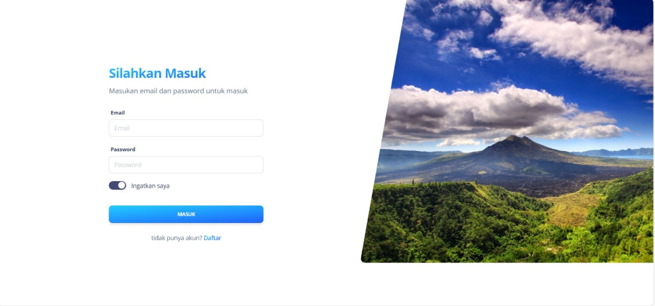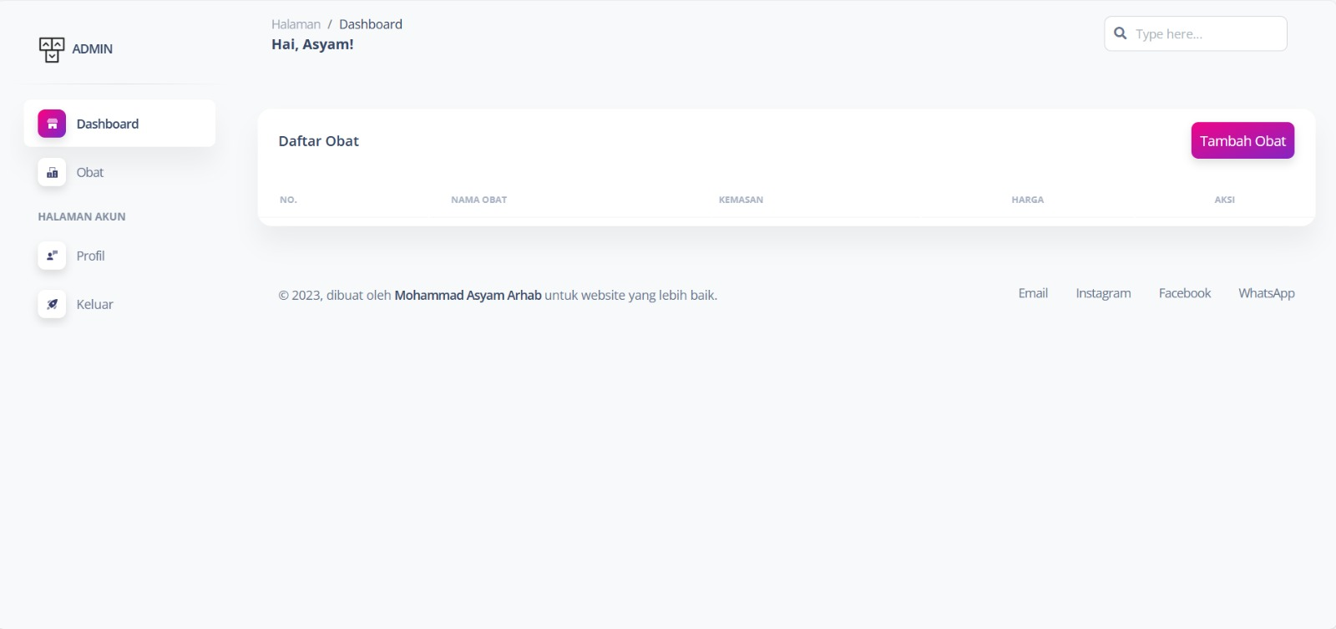SS Project